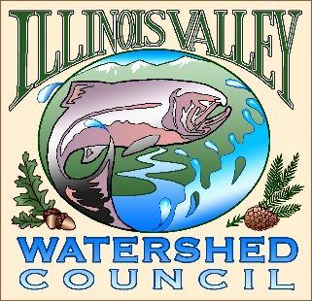 | Illinois Valley Watershed Council  331 E Cottage Park Suite 1B - P.O. Box 352  Cave Junction, OR 97523  Phone: 541-592-3731

Monthly Council Meeting Agenda

January 11, 2023

- 5:00 PM: Call to Order
- 5:05 PM: Acceptance of Minutes
- 5:10 PM: Acceptance of Financial Reports
- 5:15 PM: Old Business
  - Strategic planning review
  - Land Acknowledgement proposal

- 5:50 PM: New Business
  - Approval of by-laws
  - Election of 2024 officers
  - Approval of 2024-2026 Strategic Plan
  - Budget committee report/recommendation

- 6:20 PM: Council Updates & Staff Reports
  - Kevin report
  - Arlyse report

- 6:30 PM Partnering Agency Reports
  - Illinois Valley SWCD
  - Others

- 6:45 PM: Public Comments (Relating to this agenda or IVWC Operations)

- 7:00 PM: Adjournment

